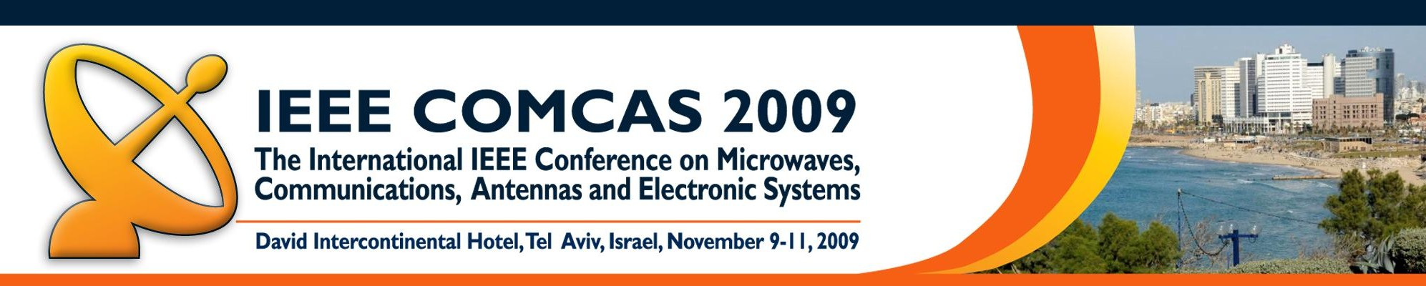


Steering Committee

Conference Chairman:

Shmuel Auster

Elta Systems Ltd.

IEEE AP/MTT Chapter Chair, Israel

Technical Program Committee Co-Chairmen:

Barry S. Perlman

US Army CERDEC, USA

IEEE MTT-S 2009 President

Roger Pollard

University of Leeds, UK
IEEE VP-TAB 2009

Publications Chairman: Benjamin Epstein

OpCoast LLC, USA

Global Administration:
Charlotte Blair
Sonnet Software Inc., USA

Awards and Sponsorship:
Barry M. Alexia
Rockwell Collins, USA

Exhibition:

Oren Hagai

Interlligent, Israel

Finance:

Yossi Pinhasi

Ariel University Center, Israel

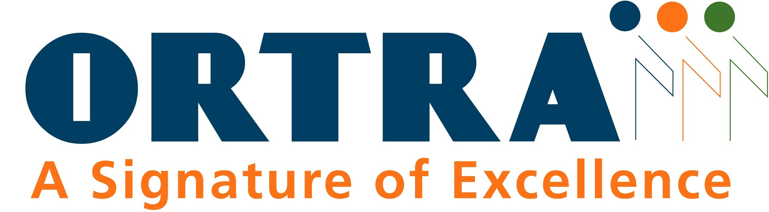
Secretariat: (all inquiries)

Ortra Ltd

1 Nirim Street, P. O. Box 9352

Tel-Aviv 61092, Israel

Tel: +972 - 3 – 6384444
Fax: +972 - 3 - 6384455

comcas@ortra.com

COMCAS 2009 continues the tradition of providing a multidisciplinary forum for the exchange of ideas in the areas of microwaves, antennas, communications, solid state integrated circuits, sensing and electronic systems engineering. The venue will be exciting and enjoyable with many opportunities for networking, candid exchange of ideas and a strong sense of community. This year we will expand the program to include RF and microwave photonics, biomedical technologies, cognitive radios and networks, radar, radio frequency identification, electron devices and photonic means for IC inspection among other topics. A diverse assembly of researchers, engineers and scientists will be invited to present their ideas and discuss new results, providing a unique opportunity for attendees to view a variety of interesting and innovative technologies in one location. Invited papers and tutorial talks from international experts will be presented in key topical areas. So please join us for the 2nd Annual IEEE COMCAS meeting in the exciting and vibrant city of Tel Aviv, Israel from 9-11 November 2009.
Original manuscripts are solicited in research areas related to Microwaves, Antennas, Communications, Integrated and Solid State Circuits, EMC, Electron Devices, and Electronic Systems including but not limited to the following: Active and Passive MW Components, RF Filters, Advanced Devices and Signal Processing for Communications, RFICs, MMICs, Low Power Solid State Circuits, Solid State and Vacuum Devices, High Power Amplifiers, RF Photonics, Nanoplasmonics, Novel Antennas, Spectrum Data Base Issues, Phased Arrays, Sensors and Sensor Systems, Radars, Hyperspectral Imaging, Wireless and Cellular Communications, AdHoc, Sensor and Mesh Networking, C3/C4 Modeling Simulation & Analysis, RF and Wave Propagation to MMW Wavelengths, MW GaAs and GaN technologies, Modeling for EMC, MW Packaging and Interconnects, MEMs, Ultra-wide Band Technology, Metrology and Parameter Extraction, Space-time Adaptive Processing, Cognitive Radios/Radar and Spectral Processing and related areas.

Regular oral presentations will be 20 min. in length; there will also be Poster sessions.

All submitted papers will be peer reviewed and assessed on key accomplishments, contribution to technology, advancement of the state-of-the-art, originality and interest to the attendees. Accepted papers will be published in the COMCAS 2009 Proceedings which will be available through IEEE Xplore after the conference.

Papers should first be submitted as a 1 to 2 page summary. Please refer to the detailed author instructions provided on the conference website www.comcas.org
Deadline for Summary Submission: 8 July 2009.
Authors of accepted papers will be required to submit a final complete manuscript (4 to 10 pages) online in PDF format no later than 30 September 2009.

The official language of the Conference is English.

Technical Program Committee

Barry S. Perlman, co-chairman

Roger Pollard, co-chairman

Edward Ackerman

Barry M. Alexia

Shmuel Auster

Tamara Baksht

Constantine Balanis

Jennifer T. Bernhard
Charlotte Blair

Amir Boag

Andreas Cangellaris
Jocelyn Chanussot

William Chappell

Franz Dielacher

Frank Ellinger
Benjamin Epstein

Franco Giannini

Richard Gitlin

Gady Golan

Paul R. Hartmann

Wolfgang Heinrich

William A. Imbriale

Anthony Immorlica

Magdy Iskander

Dieter Jaeger

William Jemison

Elya Joffe

Bumman Kim

Ken-Ichi Kitayama

Joy Laskar

Yehuda Leviatan

Newton Love

Robert Mailloux

Robert McMillian

Joseph (Joe) Mitola

Józef Modelski

Moshe Netzer

Ali Niknejad

John Papapolymerou

Dimitrios Peroulis

Yossi Pinhasi

Raymond Quéré

Jeff Reed

Arie Reichman

Robert Reuss

Arye Rosen

Ruth Rotman

Stanley Rotman

Mark Ruberto

Dominique Schreurs

Reuven Shavit

Solon Spiegel

Mark Stockman

Manos Tentzeris

Robert Trew

Moshe Tur

Neil Vallesteros

Frank Van Den Bogaart

Frank Van Vliet

Rama Venkatasubramanian

John Volakis

Martin Vossiek

Robert Weigel

Ke Wu

Siddik Yarman

Amir I. Zaghloul

Zeev Zalevsky

Nikolay Zheludev










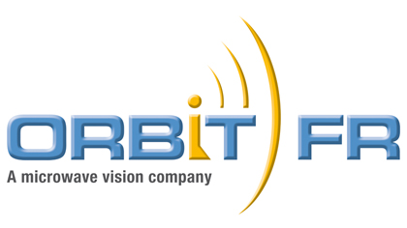


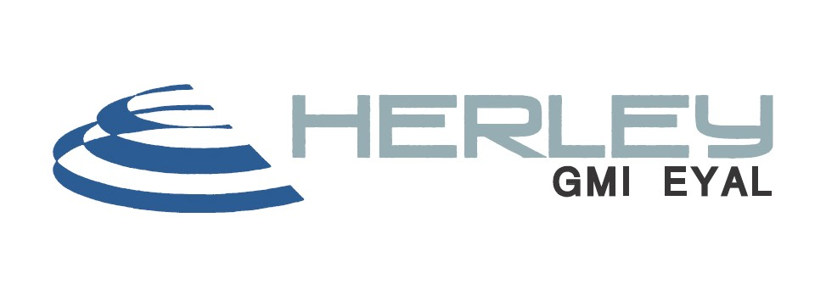
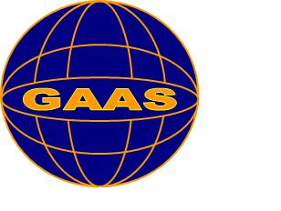

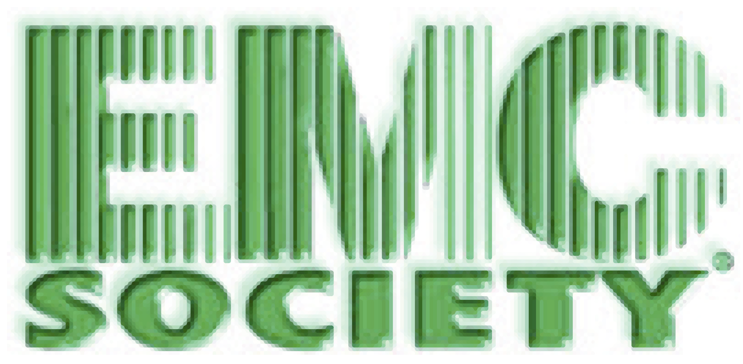




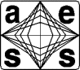
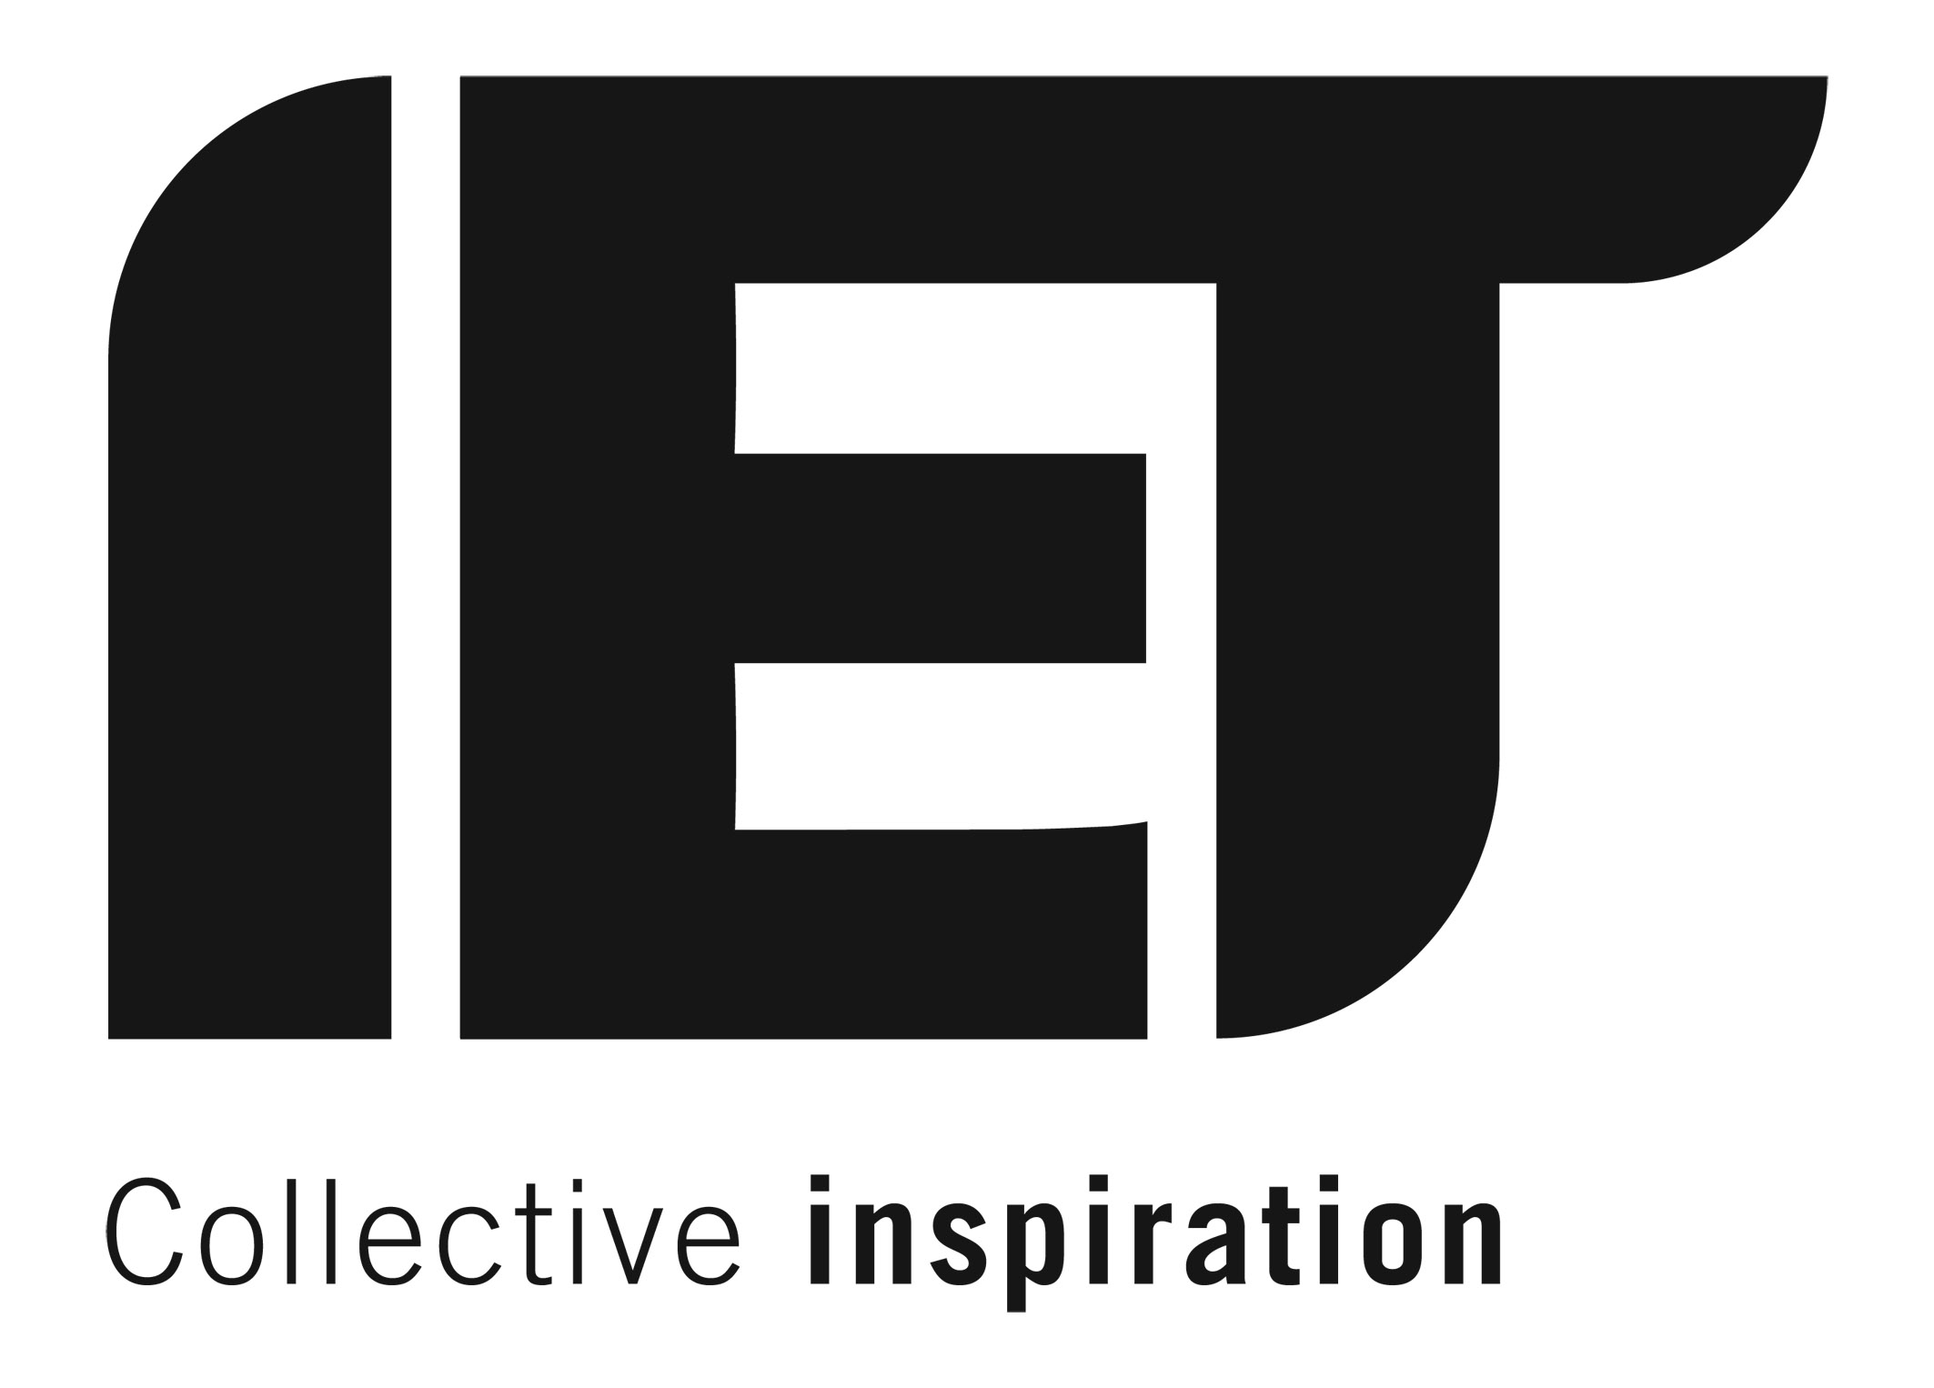
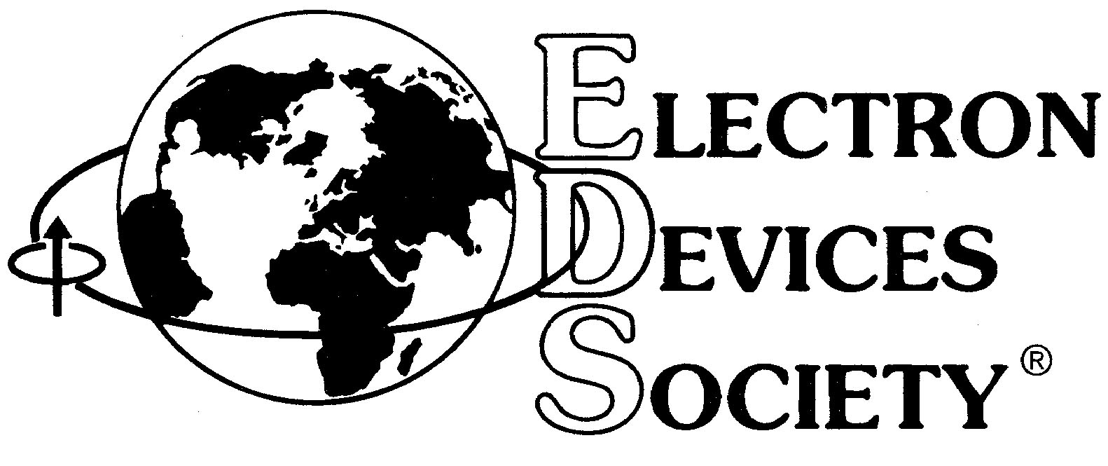
Platinum Patrons:
Technical Sponsors:
Supported by the IET Israel Network
Media Support:
Gold Patrons:

Complete information on how to submit a paper and register for the conference, as well as other important information, is available on the conference website http://www.comcas.org
Keynote Speaker:

Joseph (Joe) Mitola, Stevens Institute of Technology, NJ, USA

“Cognitive Radio Research and Commercialization Challenges and Opportunities”

Technical Topics:
- Ad Hoc, Sensor and Mesh Networking
- Antennas (components, modeling, phased array, etc.)
- Biomedical Technologies
- Cognitive and Software-Defined Radios and Networks
- Communications Systems, Modeling, Simulation and Analysis
- Computational Electromagnetics and Wave Propagation
- Electromagnetic Compatibility
- Energy Harvesting and Thermal Management
- Hyperspectral Imaging and Remote Sensing
- MEMS (Modeling, Devices, Applications)
- Mixed Signal Analog/RF/Digital Circuits and Systems
- Microwave and MM-wave circuit technologies
- Nanoplasmonics and Metamaterials
- RF/Microwave Photonics
- Power Amplifiers and Electron Devices
- Radar and Electronic Systems
- RFID Devices, Technologies and Systems
- Solid State Devices, RFICs, Circuits and Modeling
- Terahertz Technology & Applications

The technical program will be complemented with a Technical Exhibition, which will be held on November 9-10, offering companies and agencies a unique opportunity to visit Israel and present related products and services in display and printed advertisement.
For further details please contact the Conference Secretariat.

Important Deadlines:
Summary Submission: 8 July 2009
Notification of Acceptance: 22 August 2009
Final Manuscript Submission: 30 September 2009

